CITS3003 Graphics & Animation2020

Project 1

Student Name: ShiKai Wang

Student ID: 21938451

**Overview**

From part A to part J all functionalities have been implemented successfully. However, there is a problem that cannot be solved, which is the camera coordinate jump to another coordinate when I initially clicked the mouse. The second thing is I don’t have the appropriate mouse for Mac computer, so the middle button of mouse function cannot be tested.

The note below demonstrates my progress.

**Part A camera Rotate:**

The purpose of task A is to rotate the camera via X and Y axes since variables camRotUAndOverDeg and camRotSidewaysDeg are already provided when moving the mouse with press down button. I used Rotate function to rotate x and y axes with these two argument. Variable viewDist is related to Z axes (forwards and backwards) when scroll the mouse wheel so it should combine with translations. Below screenshot demonstrates it.

However, I have found that the Part A video mouse coordinate is different to skeleton code that provided as mouse won’t store the current position.

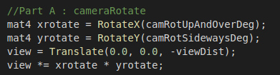

**Part B objectRotateXYZ:**

This part is similar to task A as they both rotate through X, Y, and Z axis and the only difference is that A rotates the camera. However, task B rotates the specific object. I have successfully implemented this functionality as following sceneObject structure using array of angles to store and distinguish X, Y, and Z dimension. Finally, use variable rotate to multiply with translate and scale, and then set the model.

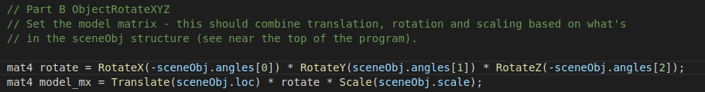

**Part C materials:**

As following the instruction, I have implemented ambient, diffuse, specular light, and shine from sceneObject structure and used setToolCallbacks function.

The first thing I have done is modify the makeMenu() function to see which port of materialMenu interact with.

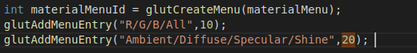

After I knew port 20 interact with these four attributes, I need to set setToolCallbacks function in materialMenu() function.

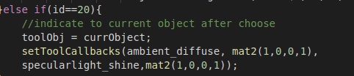

However, setToolCallbacks function requires four arguments which should changes current object’s ambient, diffuse, specular, and shine, so I need to create two functions to add these factors up when press the left mouse down. It needs to refer sceneObject structure.

Here is the code shows below:

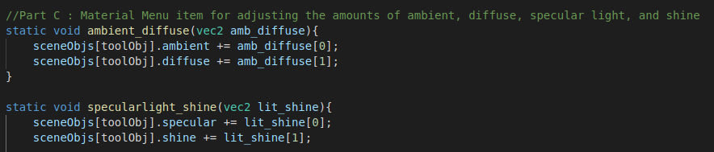

**Part D closeup:**

Initally, this question I thought it was hard to reshape after camera close to the object, but after I found reduce nearDist can closer visible objects.



**Part E reshape:**

The purpose of this part is to reshape all objects each time the window is resized. The lab5 Q3 also has the same practice experience. I have found when width is greater than height all objects will reshape. However, when window is square the object inside the window was not reshaped, so I have to add one more else if condition when height > width.

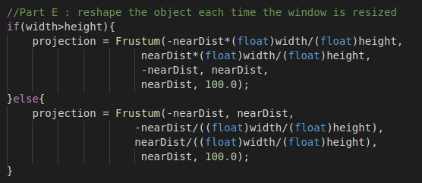

**Part F, G:**

The variable light_redu is provided to calculate the lighting after reducing the light source distance. This part is modified in fvertex.glsl



Most of the light source part from vStart.glsl has been shifted to fStar.glsl to achieve light per fragment because light direction are calculated for each fragments.

Part H, I :

There are two light sources shows below and passed their light brightness to fragment shader

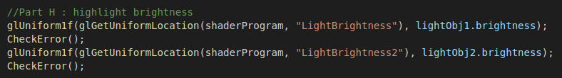

Initially, I have passed LightBrightness to the variable specular in fStar.glsl, but it doesn’t show the specular component shine towards white, so I have added another variable brightness in fragment shader and it always shine.

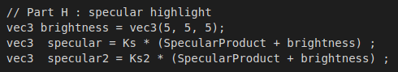

Make the second light almost the same as the first light so the second light code is initiated in init() function. The second light brightness value is greater than first light.

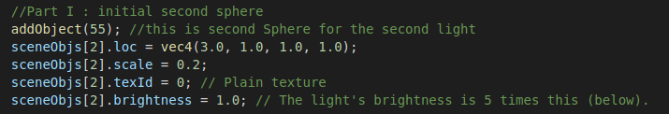

Additionally, add second light source in display () function. In fragment shader, the second light source need its independent variable: LightPosition2, LightColor2, and LightBrightness2.



Part J:

In makeMenu() function need to add delete Menu and also duplicate Menu. I choose port 90 and port 91 to delete the current object and duplicate the current object respectively.

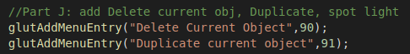

In mainenu() function added if statement to check which port it is once the left button mouse click down.

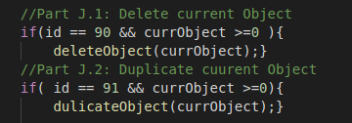

Create deleteObject() function and check how many object totally.

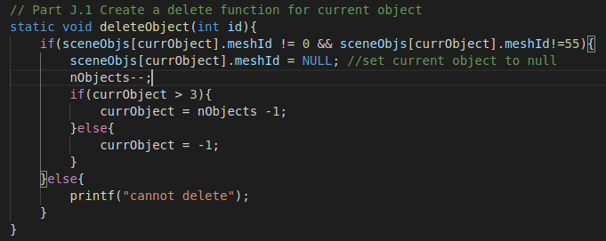

For duplicate function need to check the maximum object not over than 1024.

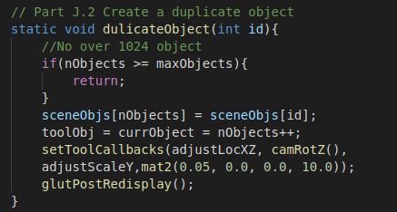

Reflection:

The environment is not very friendly for Mac as I got segmentation fault after following the instruction in ReadMe, so I have to use VirtualBox and download Linux system. At the beginning, I thought this project requires lot of code understanding before start. The instruction and video shows hint when I start to do it in each part and also some functions were already created, so I only need to understand how function works and use it properly.

I learned a lot after following the instruction step by step. It helps me understanding and strengthening the process of how graphics pipeline works.